DSA Lab Assignment 2

Cs231160

3d

Suresh Kumar

Q1

import java.util.Scanner;

public class Transpose2DArray {

public static void main(String[] args) {

Scanner sc = new Scanner(System.in);

System.out.println("Enter rows ");

int rows = sc.nextInt();

System.out.println("Enter colums ");

int cols = sc.nextInt();

int[][] OriginalAarray = new int[rows][cols];

for (int i = 0; i<rows; i++){

for (int j= 0; j<cols; j++){

OriginalAarray[i][j] = sc.nextInt();

}

}

rows = OriginalAarray.length;

cols = OriginalAarray[0].length;

int[][] TransposeArray = new int[cols][rows];

for (int i = 0; i<rows; i++){

for (int j = 0; j<cols; j++){

TransposeArray[j][i] = OriginalAarray[i][j];

}

}

System.out.println("Original Matrix");

for (int i = 0; i<rows; i++){

for (int j= 0; j<cols; j++){

System.out.print(OriginalAarray[i][j] +" ");

}

System.out.println();

}

System.out.println("Transpose Matrix");

for (int i = 0; i<cols; i++){

for (int j= 0; j<rows; j++){

System.out.print(TransposeArray[i][j]+" ");

}

System.out.println();

}

}

}

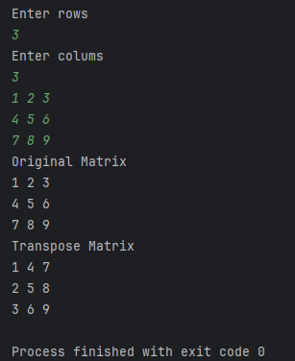

Q2

import java.util.Scanner;

public class LeftDiagonalArray {

public static void main(String[] args) {

Scanner sc = new Scanner(System.in);

System.out.println("Enter the size of the square matrix top find the some of diagonls");

int n = sc.nextInt();

int[][] TwoDArray = new int[n][n];

System.out.println("Enter the Elements in the array ");

for (int i = 0; i<n; i++){

for (int j = 0; j<n; j++){

TwoDArray[i][j] = sc.nextInt();

}

}

int leftDiagonalsum = 0;

for (int i = 0; i<n; i++){

leftDiagonalsum += TwoDArray[i][i];

}

System.out.println("The sum of left diagonal is "+leftDiagonalsum);

int rightDiagonalsum = 0;

for (int i = 0; i<n; i++){

rightDiagonalsum += TwoDArray[i][n-i-1];

}

System.out.println("The sum of right diagonal is "+rightDiagonalsum);

}

}

